Alert Triage Report
Security Alert Investigation and Validation Report
General Information
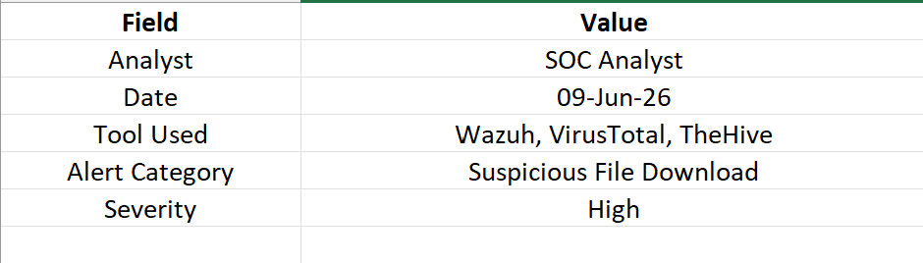
Executive Summary
This report documents the investigation and triage of a high-priority alert generated by Wazuh Security Monitoring. The alert indicated suspicious file download activity from an internal workstation. The objective was to validate the alert, determine the threat level, and implement containment measures where necessary.
Threat intelligence validation was performed using VirusTotal, while case management and documentation were handled through TheHive. The alert was confirmed as malicious, and response actions were successfully completed.

Alert Information
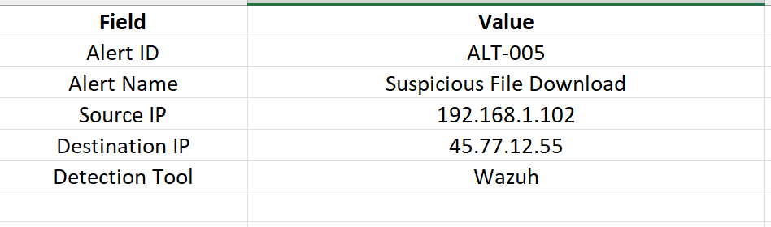
Alert Description
On 09 June 2026, Wazuh generated a high-severity alert indicating that a workstation had downloaded an executable file from an untrusted external source. The activity triggered predefined detection rules due to the file's suspicious behavior and network communication patterns.
The alert was escalated to the SOC team for investigation and validation.

Initial Triage Process
The following triage activities were performed:
- Reviewed alert details in Wazuh.
- Verified source and destination IP addresses.
- Extracted the file hash.
- Submitted the hash to VirusTotal.
- Assessed threat reputation results.
- Opened a case in TheHive.
- Applied containment measures.

Alert Details
Threat Intelligence Validation
VirusTotal Results
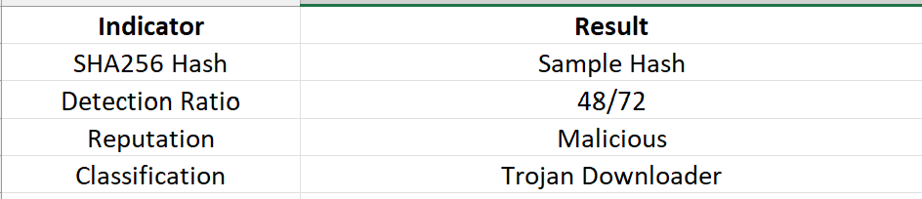
Analysis Findings
- Multiple security vendors identified the file as malicious.
- The file attempted outbound network communication.
- Behavioral indicators matched known downloader malware activity.
- Threat intelligence validation confirmed a high-risk threat.

Investigation Summary
The downloaded file was analyzed using VirusTotal and was determined to be malicious. Further endpoint review revealed attempts to contact external servers associated with malware delivery infrastructure.
No evidence of privilege escalation or lateral movement was identified. The affected workstation was isolated to prevent additional risk.

TheHive Case Information
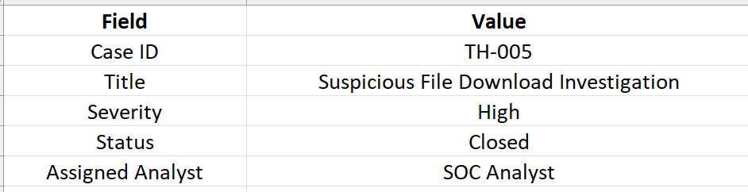
Containment Actions
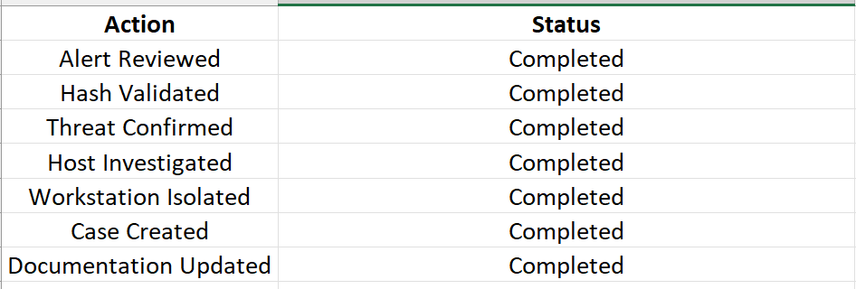
Risk Assessment
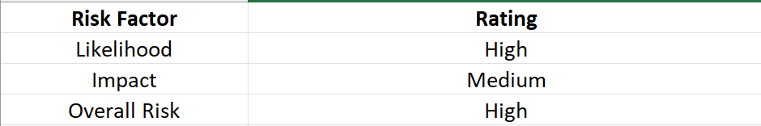
Lessons Learned
- Threat intelligence validation improves investigation accuracy.
- Automated alerting reduces detection delays.
- Endpoint monitoring remains critical for malware detection.
- Early containment minimizes organizational impact.

Recommendations
- Implement automated malware quarantine procedures.
- Expand threat intelligence integrations.
- Increase monitoring of executable downloads.
- Conduct employee security awareness training.
- Review and update detection rules regularly.

Conclusion
The alert triage process successfully identified and validated a malicious file download event. Through the use of Wazuh, VirusTotal, and TheHive, the SOC team quickly investigated the threat, confirmed malicious activity, and implemented containment actions. The incident highlighted the importance of automated monitoring, threat intelligence enrichment, and structured incident response procedures in maintaining organizational security.

